|  |  |
| --- | --- |
|  |  |
|  | Foundation Activity 3 Parallel and Series Connections |

Nodes

When two or more parts are electrically connected, we call this connection point a node.

|  |  |
| --- | --- |
| C:\Users\Harryp\MEGA\Surface Pro 2\Nepal\Himalayan Makers Guild\Activities\Foundation Activities\FA3 - Series and Parallel Connections\images\Eagle\nodes1a.png  This circuit has 3 nodes. | C:\Users\Harryp\MEGA\Surface Pro 2\Nepal\Himalayan Makers Guild\Activities\Foundation Activities\FA3 - Series and Parallel Connections\images\Eagle\nodes1a.png  This circuit has 2 nodes. |

Series Connections

Parts in series are connected one after the other in a line.

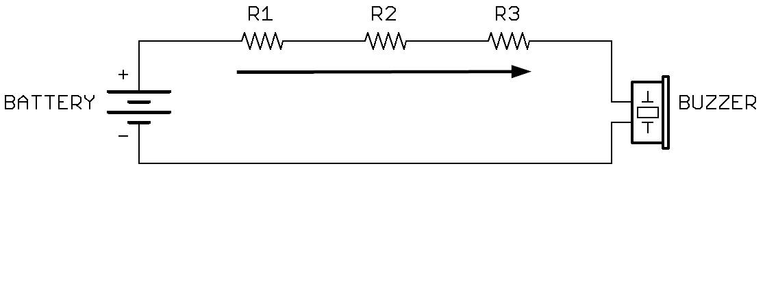

The same current flows through all the parts, in a single path.

Adding resistors in series is like adding more trees in the rock slide analogy, increasing the total resistance.

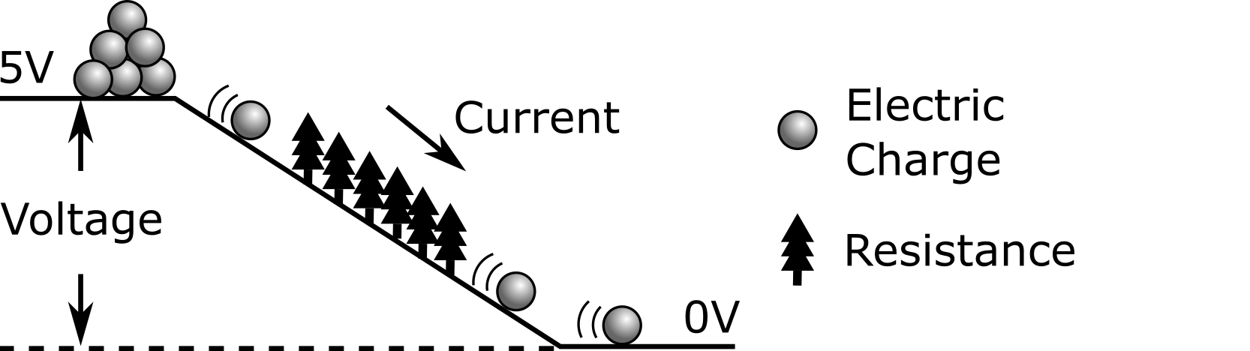

Parallel Connections

Parts in parallel are connected side-by-side.

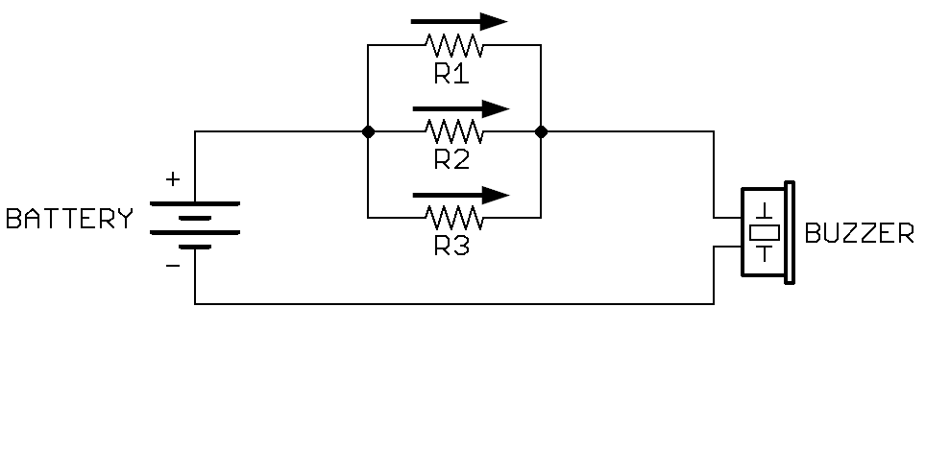

The current flows in separate paths through the circuit. The current entering the parallel circuit is the same as the current leaving.

The same voltage is applied across all the paths.

Adding resistors in parallel is like adding another hill of the same height for the rocks to slide down. So, even though we’ve added more trees, rocks can slide down both hills at the same time, increasing the total current (less resistance).

